

|  |  |  |  |  |  |  |  |  |  |  |  |  |  |  |
| --- | --- | --- | --- | --- | --- | --- | --- | --- | --- | --- | --- | --- | --- | --- |
|  |  |  |  |  |  |  |  |  |  |  |  |  |  |  |
|  |  |  |  |  |  |  |  |  |  |  |  |  |  |  |
|  |  |  |  |  |  |  | 40 | 8 | 1* |  | 39 | 8 |  |  |
|  |  |  |  |  |  |  |  |  |  |  |  |  |  |  |
|  |  |  |  |  |  |  |  |  |  |  |  |  |  |  |
|  |  |  |  |  |  |  |  |  |  |  |  |  |  |  |

Year





# Stock Inventory Dashbord

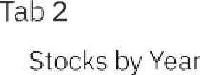

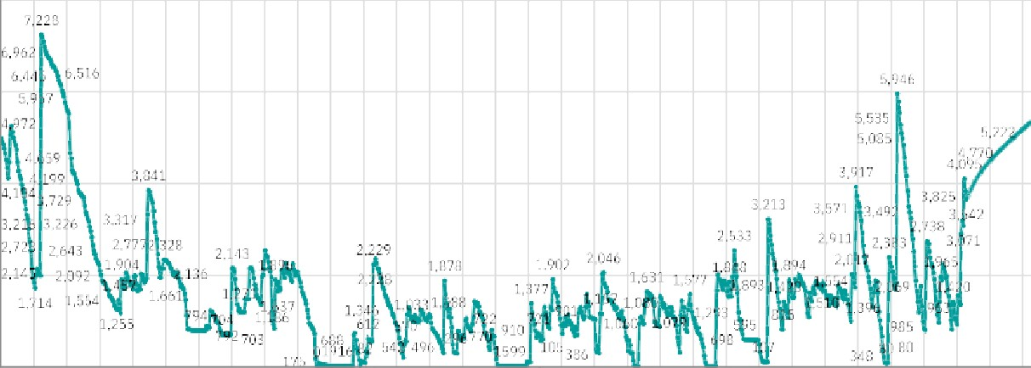

2‘5

# Stock Inventory Dashbard

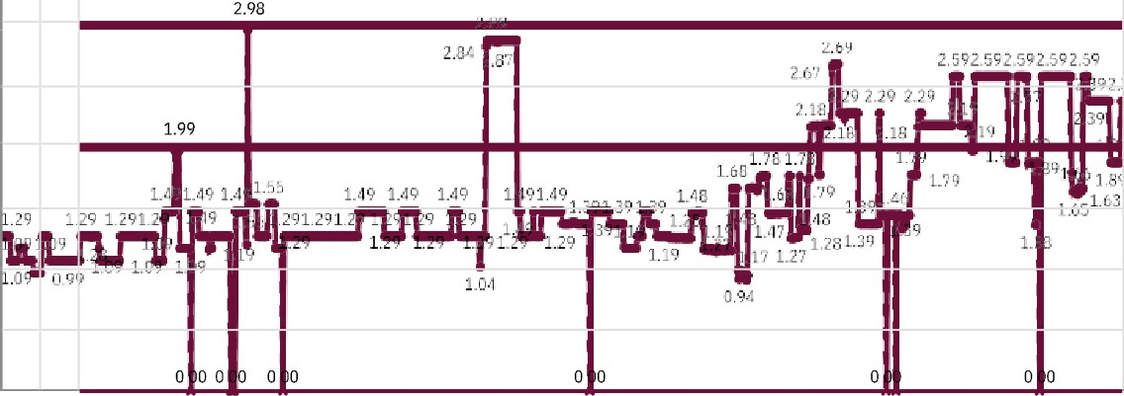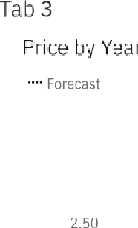

'Year





4

Forecast

200.000

Year

Tab5

SaTes by Yea

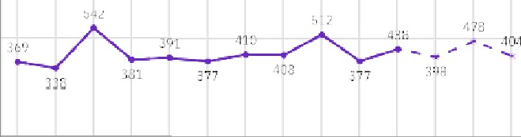



Price by Year

Stocks by year

Revenue by Yea r

G,'' ?? '' ZL" ''ñ.''Uh 4 'ñ,''2G1'^

# Stock Inventory Dashbord

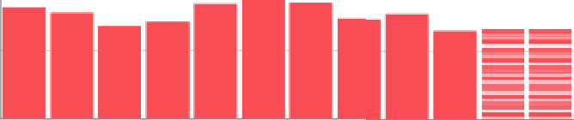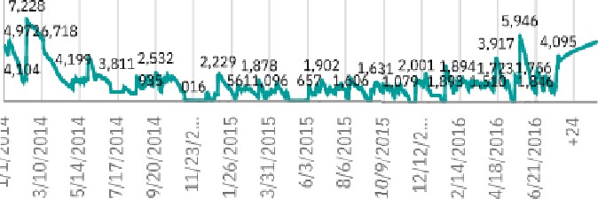I,'ñ.'' t?6 Z '7.'?'J1fi ?,'' l.' 2'3J1

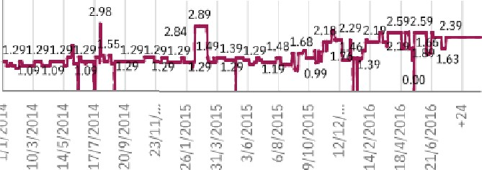.' .'' ñ.'' aJ1o 1 ''I .''2J1† ñ,''ñ.*23?t 1 .''6 ''2'J1t EU'' .*.' 2J1t 1.'...